## Final Year Project

**Traveller Assistant**



**Submitted by:** Ehsan Ali(F2019065021)

Aleena Aftab(F2019065227)

**Session:** 2019-2023  
 BS (Software Engineering)

**University of Management and Technology  
C-II Johar Town Lahore Pakistan**

**Dedication**

We express our heartfelt gratitude to the Almighty Allah for blessing us and guiding us throughout this journey. With immense joy and gratitude, we dedicate this project to our family, who have been our unwavering support, providing us with the wings to soar in the realm of technology and shaping a promising future.

In addition, we extend our sincere appreciation to our esteemed advisor, Dr. Amjad Husain Zahid, for their invaluable guidance and mentorship. Their expertise and encouragement have been instrumental in shaping the success of this project.

Moreover, we are immensely thankful to the academia of our university for their unwavering collaboration and support throughout this project. Their contribution and assistance have been truly priceless.

The journey to complete this project has been both challenging and enriching. We have embraced every obstacle as an opportunity to learn and grow, and we are humbled by the knowledge and experience gained throughout this endeavor.

Once again, we express our profound gratitude to everyone involved in this project, for their unwavering support and inspiration, which has been pivotal in making this endeavor a success.

## 

**Final Approval**

**Panel of Examiners**

* **Head of Department**  ______________________

Department of Informatics and Systems

University of Management and Technology

Lahore

* **Program Director (Final Year Projects)** ______________________

Department of Informatics and Systems

University of Management and Technology

Lahore

* **Supervisor** ______________________

Department of Informatics and Systems

University of Management and Technology

Lahore

**Project Title** Traveller Assistant

**Objective** Web Based Appliction project

**Undertaken by** Ehsan Ali

Aleena Aftab

**Supervised by** Dr. Amjad H. Zahid

**Starting Date** September 30, 2022

**Completion Date** july 20, 2023

**Tools Used: (**Vs code**,** Html, CSS, Java Script, PHP, MySQL)

**Operating System** Window-10

**Declaration Form**

I have carefully examined the documentation of the Final Year Project titled *“Traveller Assistant”*; and I endorse that this documentation complies with the standards of an undergraduate level Final Year Project report.

The document has been checked for plagiarism through Turnitin software available in UMT Library. The similarities of the document are within acceptable range.

Moreover, the accompanying CDs contain PDF of the documentation, as well as the source code and binaries with user manual and installation guide.

**FYP Advisor Name: ______________________________**

Signature: __________________ Date: ___________________

**Acknowledgment**

We sincerely and humbly thank Allah Almighty, the Source of Knowledge and Wisdom, for allowing us to successfully complete the project. We also extend our heartfelt gratitude to the Holy Prophet Muhammad, who serves as humanity's internal source of guidance and has helped us understand who our creator is.

We pay gratitude to our mentors who contributed to the completion of our project. We also acknowledged their struggle in instructing us on outstanding approaches that are practiced in corporations. We appreciate the University of Management and Technology for giving us splendid surroundings to groom in every aspect according to the modern era.

We would also appreciate Dr. Amjad Husain Zahid assistance in motivating us to make our **Traveller Assistant** different. We will never forget his endless encouragement.

**Abstract**

**Traveler Assistant** is a web application. The main purpose of "Traveler Assistant" is to guide how to conveniently book hotels, and tickets buses and for the purpose of tours. The goal of this project is to develop a system that automates the processes and activities of a travel agency. In this project, we will make it easier for you to find seats and book a train, or bus. In the current system, the customer has to contact various agencies to find out the details of the seats and book the tickets. We provide access skills to critically examine how the tourist visits and their capacity to act appropriately in addressing the consequences of tourism, locally, regionally and nationally, including visitor safety and environmental impacts. It provides benefits for the customer to plan a specific journey and have it properly executed. The 'Tours and Travels Management System' project is developed to replace the existing system which helps in keeping records of the customer's destination details as well as payments received.

Revision Chart

| Version | Primary Author(s) | Description of Version | Date Completed |
| --- | --- | --- | --- |
| Capstone-1 | Ehsan Ali  Aleen Aftab | Started working on Chapter 1&2 of documentation. | 19/10/2022 |
| Capstone-1 | Ehsan Ali  Aleena Aftab | Started working on Chapter 3&4 of documentation. | 20/11/2022 |
| Capstone 1 (Revision) | Ehsan Ali  Aleena Aftab | Starting revision on chapter 1 to 4 of Documentation | 20/4/2023 |
| Final Documentation | Ehsan Ali  Aleena Aftab | Starting revision of all  Chapters of Documentation | 8/12/2023 |

# Content

Table of Contents

Final Year Project i

1. Introduction 1

1.1 Motivations 1

1.2 Project Overview 1

1.3 Problem Statement 1

1.4 Objective 1

2. Domain Analysis 2

2.1 Customer 2

2.2 Stakeholders 2

2.3 Affected Groups with social or economic impact 2

2.4 Dependencies/ External Systems 2

2.5 Reference Documents 3

2.5.1 Related Projects 3

2.5.2 Feature Comparison 3

3. Requirements analysis 4

3.1 Requirements 4

3.1.1 Functional Requirement: 4

3.1.2 Non-Functional Requirement: 5

3.2 List of Actors 5

3.3 List of use cases 6

3.4 System use case diagram 6

3.5 Extended use cases 9

4. System Design 18

4.1 Class Diagram 18

4.2 Sequence Diagrams 19

4.2 ERD 20

5. Implementation Details 21

5.1 Development Setup 21

5.2 Development Setup 21

5.3 Contraints 21

5.3.1 Assumptions 21

5.3.2 System constraints 21

5.3.3 Restrictions 21

5.3.4 Limitations 22

6. testing 23

6.1 Extended Test Cases 23

6.2 Decision Table 32

6.2.1 code snippet 32

6.3 Traceability Matrix 34

6.3.1 RID vs UCID (requirements vs use cases) 34

7. results/output/statistics 35

7.1 %Completion 35

7.2 %Accuracy 35

7.3 %Correctness 35

8. concluion 36

9. future work 37

9.1 Other References 37

10. Appendix 38

10.1 Pre-requisites 38

# Introduction

## Traveler Assistant assists the travel manager with planning, monitoring, and analyzing business trips. Typically, it refers to a management platform that provides reporting, travel policy, and inventory of trip. However, it can also be used to describe the entire procedure of handling business travel.

## Motivations

## We are motivated and inspired to visit all kinds of website. In comparison to the average weekly salary of $1,230 for all occupations, you will make about $1,080 as a travel assistant. You may anticipate working 39 hours on average each week, just under the national average of 40 hours. A quarter of travel agencies also have part-time employees. It's also important to note that women make up roughly 80% of the travel industry in Australia. Australia as a whole has open positions, with the majority located in NSW, Victoria, and Queensland. Call center jobs are also available, albeit the majority of opportunities are office-based.

## Project Overview

Traveler Assistant website this one of the website that will help customers to book Buses tickets through this travel agency website. It is really simple and hassle-free to purchase tickets. One of the intriguing designs to work on and finish in the real world will be this one. Some people enjoy taking the bus, rail, or any other mode of transportation when they travel. It is possible to book a train or a ticket to the destination on the website of the tour management system, which is designed for a travel agency. The travel management system application is designed for a travel agency, where it is possible to reserve train or buses tickets with a description of the intended trip.

**Following are the sample artifacts for this section:**

## Problem Statement

Consider yourself a system analyst for a travel company whose clients' travel arrangements are your responsibility. It assists customers with ticket purchases, hotel reservations, and auto rentals. You have been asked to assess the demands and design of the software system the organization needs for their operations. The system supports four different consumers, hotel, and automobile rental firm types. The list of available hotels, cars, and airline tickets can be requested by the customer. For each buses ticket, the client is interested in the following information:

## Objective

Travel assistants help travel agencies with tasks like delivering information to tourists, keeping up knowledge of tourist attractions, ensuring group travel assistance, leading tours, securing pleasant lodging, and instructing visitors on points of interest.

# Domain Analysis

Domain analysis for Travel Assistant includes a comprehensive study of travel, user needs and technology trends. It assesses issues travelers face, such as language barriers, safety concerns and the complexity of trip planning.

## Customer

## Customer is a strategic vision of the company for managing relationships with customers through a variety of marketing activities, plans, and actions with expert support and flexible practise to create benefits for both the business and the customer. This vision aims to attract relationships with both current and potential customers in order to motivate and develop customers.

## Stakeholders

The stakeholders in tourism destination are local residents, local companies, media, employees, government, competitors, tourists, business associations, activists and tourism developers. Stakeholder determine in table 2.1

Table 2.1

|  |  |  |
| --- | --- | --- |
| **Stakeholder** | **Names** | **Role** |
| Project Manager | Ehsan Ali | Role in system manager. |
| Website Developer | Aleena Aftab | *The project manager’s job is to over sees the project’s process.* |
| Database Engineer | Ehsan Ali | *The web developer’s task is to ensure that the website is properly encoded* |
| Requirement Analysis | Ehsan Ali  Aleena Aftab | *The objective of requirement analysis is to study that has been gathered and determine the actual facts and feasibility of these needs* |
| End user | Admin, passengers tourism | *They can perform task like book tickets, tours after join system.* |

## Affected Groups with social or economic impact

The economic impacts of tourism include improved tax and personal income, higher living standards and more job opportunities. Sociocultural impacts are associated with interactions between people with different cultural backgrounds, attitudes and behaviors, and relationships to material goods.

## Dependencies/ External Systems

Travel assistant depends upon salaries on their level of education,years of experience. It is capable of carrying out all tasks necessary to manage travel and cost claims for other employees.

## Reference Documents

During the analysis stage, the following references have been consulted:

### Related Projects

For us to develop the following related projects were found:

Traveller Assistant provides intermediate support and assistance in case of an emergency Bus booking system, Hotel Booking system, car and tour package system

### Feature Comparison

There is comparison of similar website of our project in table 2.2. in this table we compare our website feature with these websites.

Table 2.2

|  |  |  |  |  |  |  |  |
| --- | --- | --- | --- | --- | --- | --- | --- |
| **Websites** | **User Friendly Navigation** | **Site Search** | **Call option** | **Passenger**  **Feedback** | **Booking**  **Ticket** | **Booking**  **Tour** | **Cancel**  **booking** |
| Bilal  Travel | Yes | Yes | Yes | Yes | Yes | No | No |
| Daewoo  Express | Yes | Yes | Yes | Yes | Yes | No | No |
| Bashir  Sons | No | Yes | No | No | Yes | No | No |
| Sky ways | Yes | Yes | No | Yes | Yes | No | No |
| **Traveler**  **Assistant** | **Yes** | **Yes** | **Yes** | **Yes** | **Yes** | **Yes** | **Yes** |

# Requirements analysis

Requirement Analysis of traveler assistant system involves identifying and defining the functionalities, features and specifications that the system needs to have in order to effectively assistant travelers during their journeys.

## Requirements

This part involves the requirement analysis for the Traveller Assistant, which includes functional and non-functional requirement for the system.

### Functional Requirement:

In table 3.1, we describe the function requirement like booking of packages and edit delete of buses and tours of the traveller assistant project.

Table 3.1

|  |  |  |
| --- | --- | --- |
| **#** | **Requirement** | **Description** |
| **FR1** | **ADD Packages** | The admin shall be able to add a new package in the system which is visible to the user. |
| **FR2** | **Update Package** | The admin shall update the existing package if any changes made into the tourism package according to the user requirement |
| **FR3** | **Delete Package** | Admin shall be able to delete the existing package if it can be out dated or its demand decrease from user end. |
| **FR4** | **Search Package** | Admin shall search the desire package which he want to view by package code or name. |
| **FR5** | **Book Tour Plan** | The user shall book tour plan according to their choice by searching list. |
| **FR6** | **Create Account** | The user shall create/sign UP into the system by adding their details like email, password, and mobile number |
| **FR7** | **Login** | The user shall login into the system after sign up by providing their password and username by validating his/her name from database. |
| **FR8** | **Change Setting** | The user shall change their name password and provided detail by click on personal information Icon. |
| **FR9** | **Feedback** | The user shall share their feedback by adding their comment in the by clicking on comment button about his/her experience |
| **FR10** | **Payment** | System shall Provide the facility to user to pay online fare by adding their bank account or credit/debit card |
| **FR11** | **Reserve Seat** | The user shall reserve their seat according to their package plan which he/she can be choose |
| **FR12** | **See Seat Status** | The user shall be able to see his reserve seat status and package plan cost or route |
| **FR13** | **Contact** | System shall provide the facility to contact with the staff whenever click on WhatsApp icon |
| **FR14** | **Logout** | User shall be able to logout from their account |

### Non-Functional Requirement:

In this 3.2, we describe all non- function like security usability of traveller assistant project.

Table 3.2

|  |  |  |
| --- | --- | --- |
| **#** | **Requirement** | **Description** |
| **NFR1** | **Database Security:** | An unauthorized person shall not able to access the panel and database, do not read and write the information. It should maintain the security of the client’s payment method. |
| **NFR2** | **Reliability** | Traveller Assistant shall provide a reliable environment to both customers and owner. Admin shall be able to upload delete update new packages without any error. |
| **NFR3** | **Usability** | The traveller Assistant shall use PHP in designed for user friendly environment and ease of use. |
| **NFR4** | **Availability** | The traveller Assistant shall be available for 24/7 because it offers tourists reserved tour from different places so it should be available for 24 hours. |
| **NFR5** | **Efficiency** | When an online booking of travel implemented customer can have reserved packages in an efficient manner all the functionality perform faster without any error. |
| **NFR6** | **Privacy** | The website shall protect user information, data from theft. |

## List of Actors

* **User/Passenger:** This person performs all functional activity e.g. book tickets, book tours.
* **Admin:** This person approved user request and update the tour and buses schedule.
* **Bank:** This person is link as a receiving online payment.
* **Stuff:** This person is work as agent for tour planings.

## List of use cases

* **Log in:** Allow user to provide account information and access the restricted services.
* **Sign Up:** Allow user to access in website by confirmation of Phone Number, or email.
* **Ticket Booking:** User book ticket and select seat and pay payment online.
* **Tour Booking**: User Book tour his own chooser from given tour list.
* **Cancel Request:** User cancel request of booking before 24 hours.
* **Confirmation:** User can receive confirmation message of booking tour and tickets.
* **Feedback:** User share experience of her traveling

## System use case diagram

## In figure 3.1 we show the work fllow from user side. How can a user book there tickets and tours. They can search bus and tour that are given by admin. They can cancel there booking of tickets before 2 hours ago and cancellation of tours before 2 days ago.

## Figure 3.1

## D:\Project\user.jpg

In figure 3.2, we show how a tourist book their tour. First sign in the system and see the tours that are added from admin and select the tour and pay the payment. Cancellation are possible before 2 days ago.

Figure 3.2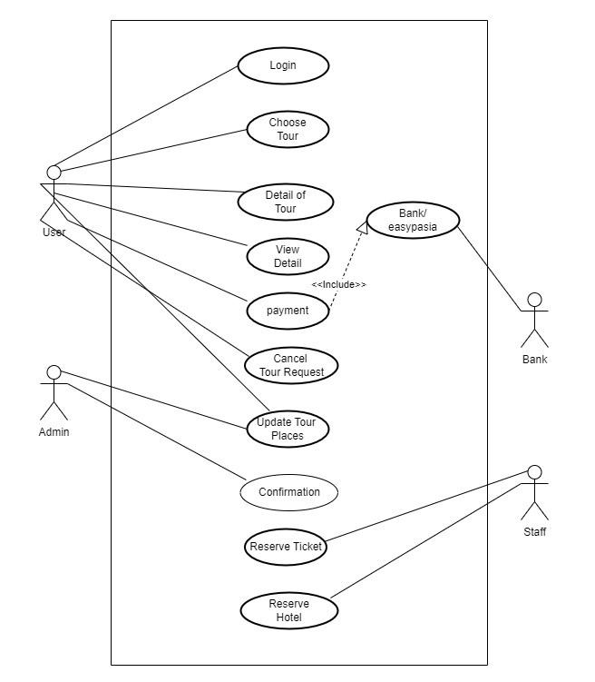

In figure 3.3, we show how a passenger book their tickets. First sign in the system and see the ticket and check the availability of seats. If available, select the seat and pay the payment. Cancellation are possible before 2 hours ago.

Figure 3.3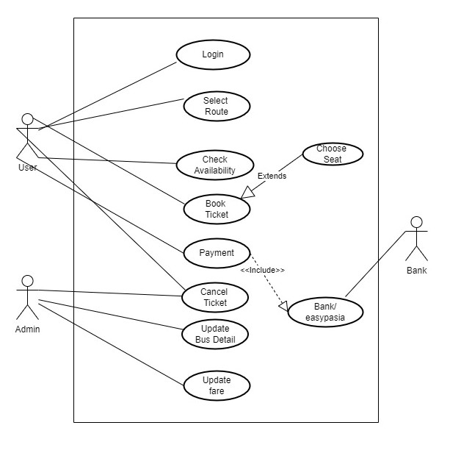

## In figure 3.4 we show the work flow from admin side. Admin are able to add new buses and tours for pessengers and tourist. Admin are able to edit or delete given packages. Admin can add new routes and new tours with description.

Figure 3.4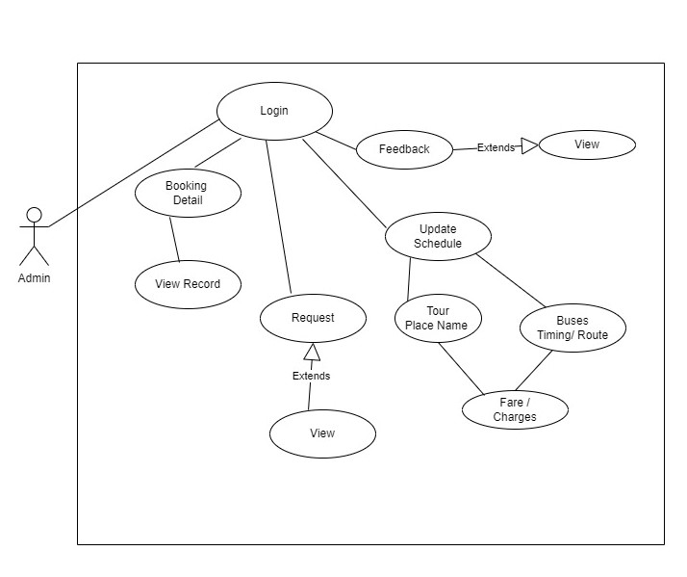

## Extended use cases

The Extended use cases for given requirements that are mentioned in Table 3.1 are given individually. The total extended use cases are 5.

**Signup/Register**

Table 3.3

|  |  |  |  |
| --- | --- | --- | --- |
| **Use Case ID:** | UC-1.2.1: Signup/Register | | |
| **Use Case Name:** | Register | | |
| **Created By:** | Ehsan Ali | **Last Updated By:** | Ehsan Ali |
| **Date Created:** | December 29, 2022 | **Last Revision Date:** | January 21, 2023 |
| **Actors:** | Passenger, admin , tourist . | | |
| **Description:** | The Actor will enter Registration Requirements for Register in our system. | | |
| **Preconditions:** | Actor must have valid required information for Register into the System. | | |
| **Post conditions:** | Actor Registration Data Will be saved. Database will be update. Actor will register into the System successfully. | | |
| **Normal Flow:** | 1. Actor enters First name for Registration. 2. Actor enters Last name for Registration. 3. Actor enters Password for Registration. 4. Actor enters Confirm Password for Registration. 5. Actor enters Phone Number for Registration. 6. Actor enters Location for Registration. 7. Actor will select the Register option. 8. System prompts the Actor for successfully Register into the System. | | |
| **Alternative Flows:**  **[Alternative Flow 1 – Not in Network]** | Not Applicable | | |
| **Exceptions:** | 1a. First Name field is empty.   1. The system shows an error message to the Actor and ask to enter valid First Name. This field cannot be empty.   1b. First Name field is containing numbers   1. The system shows an error message to the Actor and ask to enter valid First Name that is not contain numbers. This field cannot be invalid.   1c. First Name field is containing special characters   1. The system shows an error message to the Actor and ask to enter valid First Name that is not contain special characters. This field cannot be invalid.   2a. Last Name field is empty.   1. The system shows an error message to the Actor and ask to enter valid Last Name. This field cannot be empty.   2b. Last Name field is containing numbers   1. The system shows an error message to the Actor and ask to enter valid Last Name that is not contain numbers. This field cannot be invalid.   2c. First Name field is containing special characters   1. The system shows an error message to the Actor and ask to enter valid Last Name that is not contain special characters. This field cannot be invalid.   3a. Password field is empty.   1. The system shows an error message to the Actor and ask to enter valid Password. This field cannot be empty.   3b. Password field is not containing at least one special character.   1. The system shows an error message to the Actor and ask to enter Password that is containing at least one special character. This field cannot be invalid.   3c. Password field is not containing at least one Number.   1. The system shows an error message to the Actor and ask to enter Password that is containing at least one Number. This field cannot be invalid.   3d. Password field is not containing at least one Small Character.   1. The system shows an error message to the Actor and ask to enter Password that is containing at least one Small Character. This field cannot be invalid.   3e. Password field is not containing at least one Capital Character.   1. The system shows an error message to the Actor and ask to enter Password that is containing at least one Capital Character. This field cannot be invalid.   3f. Password field is not containing 8-digit.   1. The system shows an error message to the Actor and ask to enter valid 8-digit New Password. This field must contain 8-digit Password.   4a. Confirm Password field is empty.   1. The system shows an error message to the Actor and ask to enter valid confirm Password. This field cannot be empty.   4b. Confirm Password field is not match the above New Password Field.  The system shows an error message to the Actor and ask to enter confirm Password that is match the above Password. This field cannot be empty.  5a. Phone Number field is empty.   1. The system shows an error message to the Actor and ask to enter valid Phone Number. This field cannot be empty.   5b. Phone Number field is invalid.   1. The system shows an error message to the Actor and ask to enter valid Phone Number. This field cannot be invalid.   5c. Phone Number field is not containing 11-digit.   1. The system shows an error message to the Actor and ask to enter valid 11-digit Phone Number. This field must contain 11-digit phone number.   6a. Location field is empty.   1. The system shows an error message to the Actor and ask to enter valid Location. This field cannot be empty.   6b. Location field is invalid.   1. The system shows an error message to the Actor and ask to enter valid Location. This field cannot be invalid. | | |
| **Includes:** | None | | |
| **Frequency of Use:** | On Demand | | |
| **Assumptions:** | The Actor should know how to access the web page by using internet and log in by giving correct credentials. | | |
| **Notes and Issues:** | None | | |

**Login**

Table 3.4

|  |  |  |  |
| --- | --- | --- | --- |
| **Use Case ID:** | UC-1.2.2:Login | | |
| **Use Case Name:** | Login | | |
| **Created By:** | Ehsan Ali | **Last Updated By:** | Ehsan Ali |
| **Date Created:** | December 29, 2022 | **Last Revision Date:** | January 21, 2023 |
| **Actors:** | Passenger, admin , tourist. | | |
| **Description:** | The Actor will enter credentials for login in our system. | | |
| **Preconditions:** | Actor must be signup into the System. | | |
| **Post conditions:** | Actor will log in successfully. System will Show the Home Page to the user. | | |
| **Normal Flow:** | 1. Actor enters Username for Log in. 2. Actor enters Password for Log in. 3. Actor will select the login option. 4. System validates if Actor is in the system record. 5. System prompts the Actor for successfully login. | | |
| **Alternative Flows:** | If Actor forget the password   1. The system will ask the Actor to enter phone number. 2. Actor will select the Reset Password option. 3. System will ask to the Actor to enter New Password. 4. System will ask to the Actor to enter Confirm New Password. 5. Actor will press the Change Password option. | | |
| **Exceptions:** | 1a. Username field is empty.   1. The system shows an error message to the Actor and ask to enter valid Username. This field cannot be empty.   1b. Username field is invalid   1. The system shows an error message to the Actor and ask to enter valid Username. This field cannot be invalid.   2a. Password field is empty.   1. The system shows an error message to the Actor and ask to enter valid Password. This field cannot be empty.   2b. Password is invalid   1. The system shows an error message to the Actor and ask to enter valid Password. This field cannot be invalid.   3a. Phone Number field is empty.   1. The system shows an error message to the Actor and ask to enter valid Phone Number. This field cannot be empty.   3b. Phone Number field is invalid.   1. The system shows an error message to the Actor and ask to enter valid Phone Number. This field cannot be invalid.   3.1c. Phone Number field is not containing 11-digit.   1. The system shows an error message to the Actor and ask to enter valid 11-digit Phone Number. This field must contain 11-digit phone number.   3.2a. New Password field is empty.   1. The system shows an error message to the Actor and ask to enter valid New Password. This field cannot be empty.   3.2b. New Password field is not containing at least one special character.   1. The system shows an error message to the Actor and ask to enter New Password that is containing at least one special character. This field cannot be invalid.   3.2c. New Password field is not containing at least one Number.   1. The system shows an error message to the Actor and ask to enter New Password that is containing at least one Number. This field cannot be invalid.   3.2d. New Password field is not containing at least one Small Character.   1. The system shows an error message to the Actor and ask to enter New Password that is containing at least one Small Character. This field cannot be invalid.   6.2e. New Password field is not containing at least one Capital Character.   1. The system shows an error message to the Actor and ask to enter New Password that is containing at least one Capital Character. This field cannot be invalid.   3.2f. New Password field is not containing 8-digit.   1. The system shows an error message to the Actor and ask to enter valid 8-digit New Password. This field must contain 8-digit New Password. | | |
| **Includes:** | Register | | |
| **Assumptions:** | The Actor should know how to access the web page by using internet and log in by giving correct credentials. | | |

**Booking Tickets**

Table 3.5

|  |  |  |  |  |
| --- | --- | --- | --- | --- |
| **Use Case ID:** | UC-1.2.3: Booking Tickets | | | |
| **Use Case Name:** | Booking Tickets | | | |
| **Created By:** | Ehsan Ali | | **Last Updated By:** | Ehsan Ali |
| **Date Created:** | December 29, 2022 | | **Last Revision Date:** | January 21, 2023 |
| **Actors:** | | **Primary Actor:** **Passenger** is primary actor that initiates use cases such as booking, browsing and cancel tickets of touring and traveling.  **Secondary Actor: Admin** is secondary actor that is initiates use cases such as update buses schedule and also overseeing user use cases. | | |
| **Description:** | | This use case allow booking tickets , browsing schedule of buses or tours and , booking tours. | | |
| **Preconditions:** | | 1. Customer has active his account and login it. 2. Customer has a select type to booking ticket and check availability. | | |
| **Post conditions:** | | 1. Customer receives confirmation message of booking. 2. Customer collect his seat number. | | |
| **Normal Flow:** | | 1. Actor inserts Information for sign Up. 2. Actor Login Website 3. System prompts customer to choice ticket. 4. System show detail of Buses. 5. System prompts user to select from these for traveling. 6. After That they make payment for confirmation of booking 7. System prompt confirmation after payment done. 8. After that user sign out from system. | | |
| **Exceptions:** | | 2a. In step 2 of the normal flow, if the Actor invalid payment.   1. Booking is disapproved 2. Message to customer to re-try Payment. 3. Customer make again payment successfully 4. Use Case resumes on step 3 of normal flow | | |
| **Includes:** | | 1. Register 2. For booking tickets first, we login in website then we book our tickets. | | |

**Booking Tours**

Table 3.6

|  |  |  |  |  |
| --- | --- | --- | --- | --- |
| **Use Case ID:** | UC-1.2.4: Booking Tours | | | |
| **Use Case Name:** | Booking Tours | | | |
| **Created By:** | Ehsan Ali | | **Last Updated By:** | Ehsan Ali |
| **Date Created:** | December 29, 2022 | | **Last Revision Date:** | January 21, 2023 |
| **Actors:** | | **Primary Actor:** **Passenger** is primary actor that initiates use cases such as booking, browsing and cancel tickets of touring and traveling.    **Secondary Actor: Admin** is secondary actor that is initiates use cases such as update buses schedule and also overseeing user use cases. | | |
| **Description:** | | This use case allow booking tours , browsing schedule of tours and , booking tours. | | |
| **Preconditions:** | | 1. Customer has active his account and login it. 2. Customer has a select type to booking tour and check availability. | | |
| **Post conditions:** | | 1. Customer receives confirmation message of booking. | | |
| **Normal Flow:** | | 1. Actor browser tour which he/she want 2. Actor Login Website 3. System prompts customer to choice ticket and tour. 4. Actor select tour and choice. 5. Actor select tour After That they make payment for confirmation of booking 6. System prompt confirmation after payment done. 7. Actor sign out from system. | | |
| **Exceptions:** | | 2a. In step 2 of the normal flow, if the customer enters invalid payment.   1. Booking is disapproved 2. Message to customer to re-try Payment. 3. Customer make again payment successfully 4. Use Case resumes on step 3 of normal flow | | |
| **Includes:** | | 1. Register 2. For booking tickets first, we login in website then we book our tickets. | | |

**Cancel booking**

Table 3.7

|  |  |  |  |  |
| --- | --- | --- | --- | --- |
| **Use Case ID:** | UC-1.2.5: Cancel Booking | | | |
| **Use Case Name:** | Cancel Booking | | | |
| **Created By:** | Ehsan Ali | | **Last Updated By:** | Ehsan Ali |
| **Date Created:** | December 29, 2022 | | **Last Revision Date:** | January 21, 2023 |
| **Actors:** | | **Primary Actor:** **Passenger** is primary actor that initiates use cases such as booking, browsing and cancel tickets of touring and traveling.  **Secondary Actor: Admin** is secondary actor that is initiates use cases such as update buses schedule and also overseeing user use cases. | | |
| **Description:** | | This use case allow cancel tours and Ticket Booking before 2 hour. | | |
| **Preconditions:** | | 1. Customer has active his account and login it. 2. Customer has book his ticket and tour. | | |
| **Post conditions:** | | 1. Customer receives confirmation message of cancel of booking. | | |
| **Normal Flow:** | | 1. Actor Login Website 2. Actor select tour and ticket for canceling. 3. System prompt confirmation of cancel of booking and payment back in 24 hours. 4. Actor sign out from system. | | |
| **Exceptions:** | | 2a. In step 2 of the normal flow, if the Actor cancel booking after 2 hours.   1. Cancel of booking is disapproved. 2. Message to actor not allowed. 3. Use Case resumes on step 3 of normal flow. | | |
| **Includes:** | | 1. Register 2. For cancelation of booking first, we login in website and book tickets or tours. | | |

# System Design

Designing a comprehensive travel assistant system involves structuring various components and interactions to ensure seamless functionality and a user-friendly experience.

## Class Diagram

Class diagram describe the structure of project by showing the classes, Attributes, operations and the relationship among the object.

Figure 4.1

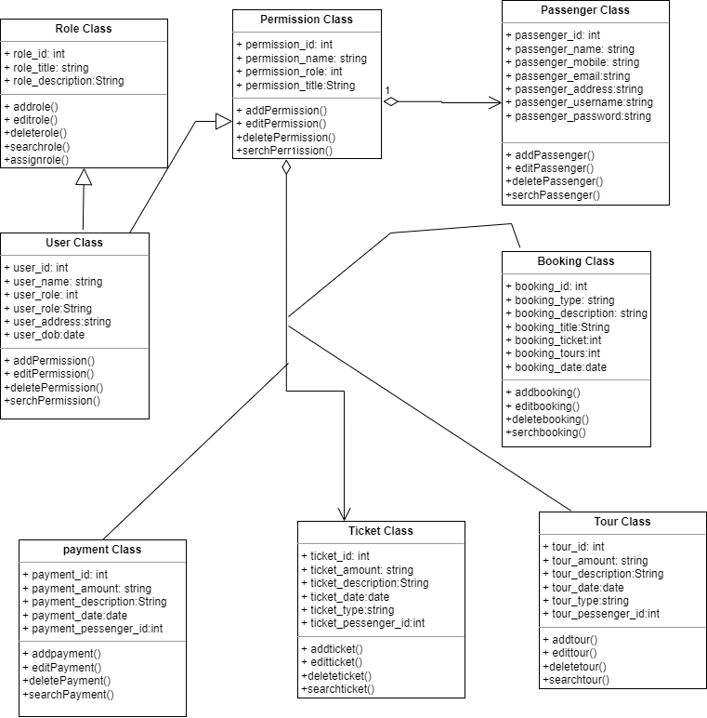

Figure 4.2

## .C:\Users\Ahsan Rajpoot\Downloads\Untitled Diagram-Page-1.drawio.png

## 4.2 Sequence Diagrams

This diagram includes all the Sequence diagrams of the functional requirements of Traveler Assistant system project along with the aggregated Sequence diagram.

Figure 4.3

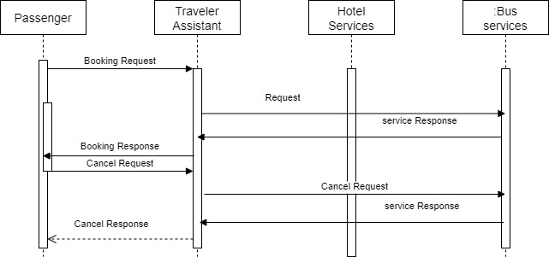

## ERD

## Entity Relationship diagram with complete relationship with dependancies of our assistant traveller system project.

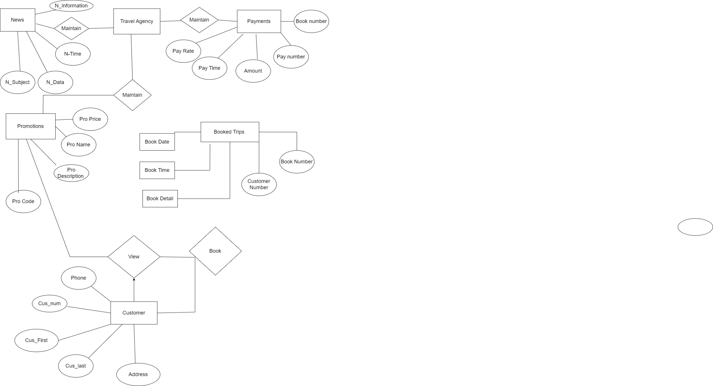Figure 4.4

# Implementation Details

The implementation of Travel Assistant includes its development for iOS and Android platforms using native programming languages ​​(Swift for iOS and Kotlin for Android). The frontend is designed with a modern, intuitive user interface following platform-specific design guidelines. The application communicates with a cloud server hosted on a scalable platform (such as AWS or Azure) using a RESTful API to exchange data.

## Development Setup

The tools and software used in this project are list below:

1. HTML
2. CSS
3. PHP
4. JavaScript
5. Draw.io
6. MySQL

## Development Setup

Our Advisor and senior friends helped setup the development. It will be an admin panel and user panel. Admin will add, delete, update and edit buses and tours for booking. We made many mistake and face many hurdles while working on this project, but it is very helpful for our experience.

## Contraints

## The user must be connect to internet because it is web-based project.

* The tour and ticket booking will be available only to registered users.
* The system must authenticate the users and validate the database records.

### Assumptions

* The user must be able to create account on the website.
* The system will authenticate user information.
* The user is aware of how to book ticket and tours.
* The user sees their booking and also cancel it if he wants.

### System constraints

* Only authenticate user will be able to book and cancel their ticket and tours.
* Only admin add, delete and update tour and buses schedule.
* The user will able to see ticket and tour but for booking first register account.
* User will book only available seats from bus.

### Restrictions

* Needs internet connection for booking
* Email and phone number required for registration
* User will able to cancel their ticket before 2 hours ago.
* User will able to cancel their tour before 2 days ago.

### Limitations

* Travel assistant website will not work with internet connection.
* The user booking only available tours and ticket of buses.

# testing

The testing phase includes a thorough assessment of the functionality and performance of the Travel Assistant. It includes unit testing to verify individual components, integration testing to ensure seamless interactions, and user acceptance testing to verify its usability. Real-world scenarios such as route planning, alerts and language translation are simulated to identify errors and faults. Performance testing measures the response of an application under various network conditions and user load.

## Extended Test Cases

**Table 6.1: TC_1 (Sign Up)**

|  |  |  |  |  |  |  |  |
| --- | --- | --- | --- | --- | --- | --- | --- |
| **Test Case ID:** TC_1 | | | | **Test Design By:** Ehsan Ali | | | |
| **Test Module Name:** Sign Up | | | | **Test Design Date:**10/06/2023 | | | |
| **Test Priority:** High | | | | **Test Executed By:** Ehsan Ali, Aleena | | | |
| **Test Title:** To test the Sign Up | | | | **Test Executed Date:**16/06/2023 | | | |
| **Description:** User signing up in order to use the website. | | | |  | | | |
| **Pre-Condition:**   1. The user must have internet access to open website. 2. The user must have an email account to sign up. 3. The user must have an phone number. | | | | | | | |
| Dependencies: | | | | | | | |
| **Step** | **Test Step** | **Test Data** | **Expected Result** | | **Actual Result** | **Status** | **Notes** |
| 1 | User opens the Traveler Assistant website |  | The website is opened successfully | | The website is opened successfully | pass       pass     pass |  |
| 2 | System asks the user to Sign-in or Sign-up |  |  | |  |
| 3 | System validates if  User has valid email address , Phone Number and Password. |  | Email, Number and Passwords valid and user can login. | | Email and Passwords valid and user can Sign up. |
| 4 | System prompts that user is registered successfully |  | The user is registered successfully | | The user is registered successfully | pass |  |
|  | | | | | | | |

The Signup Test is being in Table 6.1 above, which can detail of test case ID and executed and design by us. The user must provide phone number, email and password are need for signup in the system before clicking signup button. A new user is registered and test is pass the anticipated outcomes.

**Table 6.2: TC_2(Sign_in)**

|  |  |  |  |  |  |  |  |
| --- | --- | --- | --- | --- | --- | --- | --- |
| **Test Case ID:** TC_2 | | | | **Test Design By:** Ehsan Ali | | | |
| **Test Module Name:** Sign In | | | | **Test Design Date:**10/06/2023 | | | |
| **Test Priority:** High | | | | **Test Executed By:** Ehsan Ali, Aleena | | | |
| **Test Title:** To test the Sign IN | | | | **Test Executed Date:**16/06/2023 | | | |
| **Description:** User signing up in order to use the website. | | | |  | | | |
| **Pre-Condition:**   1. The user must have internet access to open website. 2. The user must enter username and password. | | | | | | | |
| Dependencies: | | | | | | | |
| **Step** | **Test Step** | **Test Data** | **Expected Result** | | **Actual Result** | **Status** | **Notes** |
| 1 | User opens the Traveler Assistant website |  | The website is opened successfully | | The website is opened successfully | pass |  |
| 2 | System asks the user to Sign-in or Sign-up |  |  | |  | pass |  |
| 3 | System validates if  User has valid username and Password. |  | Username and password are valid and user can login | | Username and password are valid and user can login. | pass |  |
| 4 | System prompts that user is login successfully |  | The user is login successfully | | The user is login successfully | pass |  |
| **Post Condition:** User are on home page of traveler assistant website. | | | | | | | |

The login Test is being in Table 6.2 above, which can detail of test case ID and executed and design by us. The must enters their username and password and then click login Button in order to login in system. The test case should succeed and user login into system.

**Table 6.3:TC_3(Admin_login)**

|  |  |  |  |  |  |  |  |
| --- | --- | --- | --- | --- | --- | --- | --- |
| **Test Case ID:** TC_3 | | | | **Test Design By:** Ehsan Ali | | | |
| **Test Module Name:** to test admin login | | | | **Test Design Date:**10/06/2023 | | | |
| **Test Priority:** High | | | | **Test Executed By:** Ehsan Ali, Aleena | | | |
| **Test Title:** To test the admin login feature | | | | **Test Executed Date:**16/06/2023 | | | |
| **Description:** Admin signing in in order to use the website. | | | |  | | | |
| **Pre-Condition:**   1. The user must have internet access to open website. 2. The user must enter username and password. | | | | | | | |
| Dependencies: | | | | | | | |
| **Step** | **Test Step** | **Test Data** | **Expected Result** | | **Actual Result** | **Status** | **Notes** |
| 1 | Admin opens the admin panel of Traveler Assistant website |  | The website is opened successfully | | The website is opened successfully | pass |  |
| 2 | For login in the website enter username and password. | Username:  Admin  Password:  Admin | The user enter correct username or password. | | The user login successfully. | pass |  |
| 3 | If the user is enter incorrect data or not valid. | Data is reject | User not allowed to login to the website | | The user not entered in the website. | pass |  |
| **Post Condition:** system ask to enter correct password. | | | | | | | |

The login Test is being in Table 6.3 above, which can detail of test case ID and executed and design by us.

**Table 6.4:TC_4(book ticket)**

|  |  |  |  |  |  |  |  |
| --- | --- | --- | --- | --- | --- | --- | --- |
| **Test Case ID:** TC_4 | | | | **Test Design By:** Ehsan Ali | | | |
| **Test Module Name:** booking ticket | | | | **Test Design Date:**10/06/2023 | | | |
| **Test Priority:** High | | | | **Test Executed By:** Ehsan Ali, Aleena | | | |
| **Test Title:** To test the tickets | | | | **Test Executed Date:**16/06/2023 | | | |
| **Description:** User can book ticket | | | |  | | | |
| **Pre-Condition:**   1. The user must have internet access to open website. 2. For ticket booking, user are login into the website | | | | | | | |
| Dependencies: | | | | | | | |
| **Step** | **Test Step** | **Test Data** | **Expected Result** | | **Actual Result** | **Status** | **Notes** |
| 1 | User opens the Traveler Assistant website |  | The website is opened successfully | | The website is opened successfully | pass |  |
| 2 | System asks the user to Sign-in or Sign-up |  |  | |  | pass |  |
| 3 | User can search there ticket and select it | Ticket is selected | The ticket detail are display. | | The ticket detail are displayed. | pass |  |
| 4 | User can make change or update their ticket before booking. |  | Back to ticket booking | | Back to the ticket booking | pass |  |
| 5 | User make payment. | Add payment | Pay by the PayPal | | Pay by the PayPal | Pass |  |
| **Post Condition:** User can see their ticket booking. | | | | | | | |

The ticket booking Test is being in Table 6.4 above, which can detail of test case ID and executed and design by us. The user must login in website and search bus and select the ticket. After that user can make payment. The ticket is book successfully or our test are pass.

**Table 6.5:TC_5(Tour booking)**

|  |  |  |  |  |  |  |  |
| --- | --- | --- | --- | --- | --- | --- | --- |
| **Test Case ID:** TC_5 | | | | **Test Design By:** Ehsan Ali | | | |
| **Test Module Name:** tour booking | | | | **Test Design Date:**10/06/2023 | | | |
| **Test Priority:** High | | | | **Test Executed By:** Ehsan Ali, Aleena | | | |
| **Test Title:** To test the tour booking | | | | **Test Executed Date:**16/06/2023 | | | |
| **Description:** User can book their tour | | | |  | | | |
| **Pre-Condition:**   1. The user must have internet access to open website. 2. For tour booking, user are login into the website | | | | | | | |
| Dependencies: | | | | | | | |
| **Step** | **Test Step** | **Test Data** | **Expected Result** | | **Actual Result** | **Status** | **Notes** |
| 1 | User opens the Traveler Assistant website |  | The website is opened successfully | | The website is opened successfully | pass |  |
| 2 | System asks the user to Sign-in or Sign-up |  |  | |  | pass |  |
| 3 | User can search there tour and select it | Tour is selected | The tour detail are display. | | The tour detail are displayed. | pass |  |
| 4 | User can confirm their tour . |  | Tour are book make payment | | Tour are book make payment | pass |  |
| 5 | User make payment. | Add payment | Pay by the PayPal | | Pay by the PayPal | Pass |  |
| **Post Condition:** User can see their tour booking. | | | | | | | |

The tour booking Test is being in Table 6.5 above, which can detail of test case ID and executed and design by us. The user can login website select tour that are given from admin and make the payment. The tour is booked successfully and test are passed.

**Table 6.6:TC_6(ticke_cancel)**

|  |  |  |  |  |  |  |  |
| --- | --- | --- | --- | --- | --- | --- | --- |
| **Test Case ID:** TC_6 | | | | **Test Design By:** Ehsan Ali | | | |
| **Test Module Name:** cancel ticket booking | | | | **Test Design Date:**10/06/2023 | | | |
| **Test Priority:** High | | | | **Test Executed By:** Ehsan Ali, Aleena | | | |
| **Test Title:** To test the cancellation of ticket booking | | | | **Test Executed Date:**16/06/2023 | | | |
| **Description:** User can cancel their booking. | | | |  | | | |
| **Pre-Condition:**   1. The user must have internet access to open website. 2. For tour booking, user is login into the website 3. For cancelation first ticket are booked. | | | | | | | |
| Dependencies: | | | | | | | |
| **Step** | **Test Step** | **Test Data** | **Expected Result** | | **Actual Result** | **Status** | **Notes** |
| 1 | User opens the Traveler Assistant website |  | The website is opened successfully | | The website is opened successfully | pass |  |
| 2 | System asks the user to Sign-in or Sign-up |  |  | |  | pass | After signup |
| 3 | User can go to my account and click on bus booking. |  | Show ticket booking that are booked. | | Show ticket booking that are booked | pass |  |
| 4 | User can click on the cancel button |  | Prompt are show of cancel booking | | Prompt are show of cancel booking | pass |  |
| 5 | User can click ok. |  | Ticket are cancel | | Ticket are cancel | Pass |  |
| **Post Condition:** | | | | | | | |

The ticket cancelation Test is being in Table 6.6 above, which can detail of test case ID and executed and design by us. For ticket cancelation pre-condition is your ticket are booked. First you can go to my account to see booking of ticket and then cancel the booking. Ticket are cancel successfully and test are passed.

**Table 6.7:TC_7(Tour cancelation)**

|  |  |  |  |  |  |  |  |
| --- | --- | --- | --- | --- | --- | --- | --- |
| **Test Case ID:** TC_7 | | | | **Test Design By:** Ehsan Ali | | | |
| **Test Module Name:** cancel tour booking | | | | **Test Design Date:**10/06/2023 | | | |
| **Test Priority:** High | | | | **Test Executed By:** Ehsan Ali, Aleena | | | |
| **Test Title:** To test the cancellation of tour booking | | | | **Test Executed Date:**16/06/2023 | | | |
| **Description:** User can cancel their booking. | | | |  | | | |
| **Pre-Condition:**   1. The user must have internet access to open website. 2. For tour booking, user is login into the website 3. For cancelation, first tour are booked. | | | | | | | |
| Dependencies: | | | | | | | |
| **Step** | **Test Step** | **Test Data** | **Expected Result** | | **Actual Result** | **Status** | **Notes** |
| 1 | User opens the Traveler Assistant website |  | The website is opened successfully | | The website is opened successfully | pass |  |
| 2 | System asks the user to Sign-in or Sign-up |  |  | |  | pass | After signup |
| 3 | User can go to my account and click on tour booking. |  | Show tours booking that are booked. | | Show tours booking that are booked | pass |  |
| 4 | User can click on the cancel button |  | Prompt are show of cancel booking | | Prompt are show of cancel booking | pass |  |
| 5 | User can click ok. |  | Ticket are cancel | | Ticket are cancel | Pass |  |
| **Post Condition:** | | | | | | | |

The ticket cancelation Test is being in Table 6.7 above, which can detail of test case ID and executed and design by us. For tour cancelation pre-condition is your tour are booked. First you can go to my account to see booking of tour and then cancel the booking. Tour are cancel successfully and test are passed.

**Table 6.8:TC_8(admin_add or delete _Bus)**

|  |  |  |  |  |  |  |  |  |
| --- | --- | --- | --- | --- | --- | --- | --- | --- |
| **Test Case ID:** TC_8 | | | | **Test Design By:** Ehsan Ali | | | | |
| **Test Module Name:** admin add bus | | | | **Test Design Date:**10/06/2023 | | | | |
| **Test Priority:** High | | | | **Test Executed By:** Ehsan Ali, Aleena | | | | |
| **Test Title:** To test add bus route or delete route. | | | | **Test Executed Date:**16/06/2023 | | | | |
| **Description:** admin add or delete buses. | | | |  | | | | |
| **Pre-Condition:**   1. The user must have internet access to open website. 2. Admin login into admin panel. | | | | | | | | |
| Dependencies: | | | | | | | | |
| **Step** | **Test Step** | **Test Data** | **Expected Result** | | **Actual Result** | **Status** | **Notes** |
| 1 | User opens the Traveler Assistant admin panel website |  | The website is opened successfully | | The website is opened successfully | pass |  |
| 2 | System asks the admin to Sign-in. |  | Add username.  Add password. | | Add username.  Add password. | pass | After signup |
| 3 | Admin add bus. |  | Enter bus Number.  Enter bus type. | | Enter bus Number.  Enter bus type. | pass |  |
| 4 | Click submit button. |  | Buses added | | Bus added. | pass |  |
| 5 | Click on add bus route |  | Add city. | | Add city | Pass |  |
| 6 | Submit |  | Bus route is added | | Bus route is added | Pass |  |
| **Post Condition:** | | | | | | | | |

The ticket cancelation Test is being in Table 6.8 above, which can detail of test case ID and executed and design by us. Admin add or delete bus detail. First add bus detail then add bus route where from and where to go. And also delete bus detail.

**Table 6.9:TC_9(admin_add or delete _tour)**

|  |  |  |  |  |  |  |  |  |
| --- | --- | --- | --- | --- | --- | --- | --- | --- |
| **Test Case ID:** TC_8 | | | | **Test Design By:** Ehsan Ali | | | | |
| **Test Module Name:** admin add bus | | | | **Test Design Date:**10/06/2023 | | | | |
| **Test Priority:** High | | | | **Test Executed By:** Ehsan Ali, Aleena | | | | |
| **Test Title:** To test add bus route or delete route. | | | | **Test Executed Date:**16/06/2023 | | | | |
| **Description:** admin add or delete buses. | | | |  | | | | |
| **Pre-Condition:**   1. The user must have internet access to open website. 2. Admin login into admin panel. | | | | | | | | |
| Dependencies: | | | | | | | | |
| **Step** | **Test Step** | **Test Data** | **Expected Result** | | **Actual Result** | **Status** | **Notes** |
| 1 | User opens the Traveler Assistant admin panel website |  | The website is opened successfully | | The website is opened successfully | pass |  |
| 2 | System asks the admin to Sign-in. |  | Add username.  Add password. | | Add username.  Add password. | pass | After signup |
| 3 | Admin add tour. |  | Enter tour description.  Enter tour price. | | Enter tour description.  Enter tour price. | pass |  |
| 4 | Click submit button. |  | tour added | | tour added. | pass |  |
| 5 | Click on delete tour |  | Tour is deleted. | | Tour is deleted. | Pass |  |
| 6 | Submit |  | tour is added or deleted. | | tour is added or deleted. | Pass |  |
| **Post Condition:** | | | | | | | | |

## Decision Table

A decision table is a structured tool used to analyze complex business logic and make well-defined decisions based on various combinations of input conditions or criteria. It presents all possible scenarios or combinations of conditions in a tabular format along with the corresponding actions or outcomes. Decision tables help visualize and organize complex decision processes, making it easier to identify patterns, rules, and outcomes for different combinations of inputs. They are particularly useful for clarifying and documenting business rules, software logic, and requirements in a concise and easy-to-understand manner.

code snippet

Picture 6.1

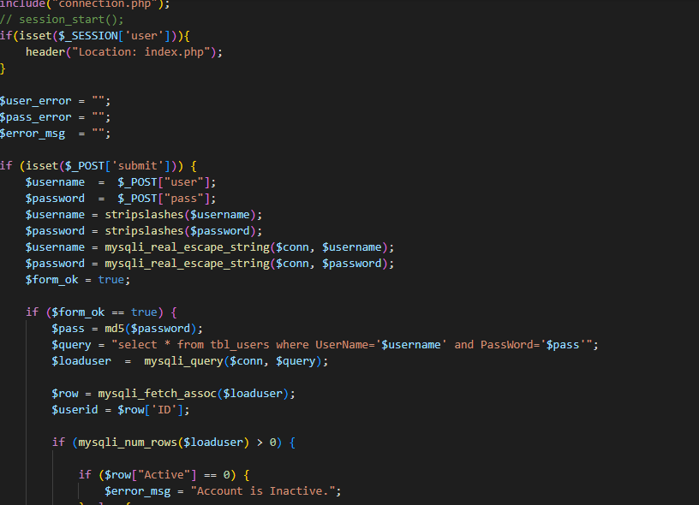

**Login**

**Picture 6.2**

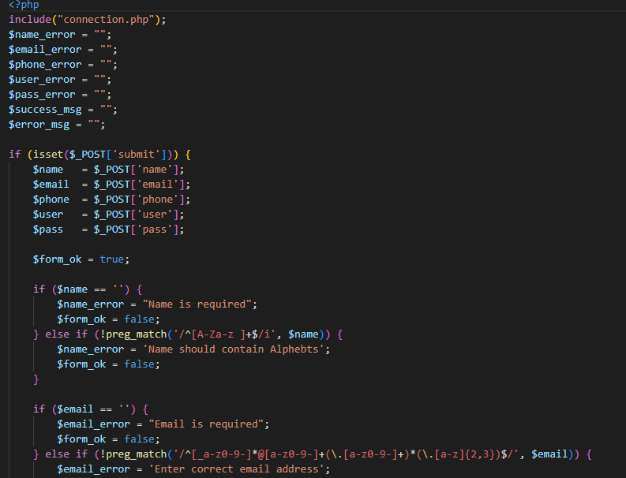

**Picture 6.3**

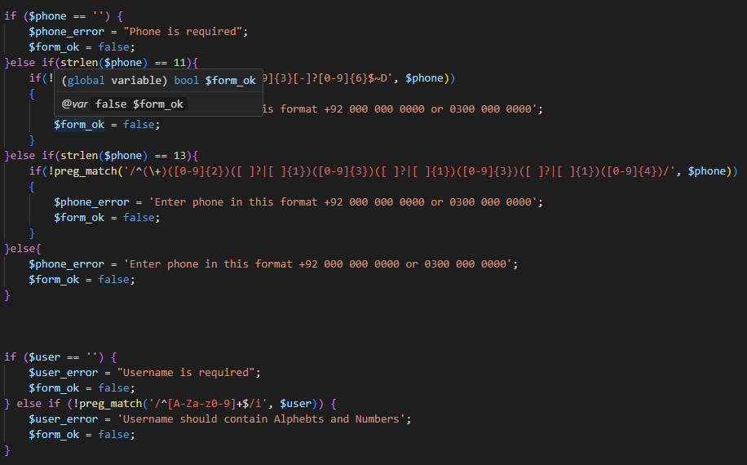

**Sign Up**

## Traceability Matrix

The Traceability Matrix is ​​a structured document that creates a clear link between the various components of the Travel Assistant application and its defined requirements. It ensures that each request is addressed by specific functions and features in the application. The matrix makes it easy to track and verify that each requirement has been successfully implemented and tested. By providing a visual representation of the alignment between requirements and implementation, the traceability matrix helps ensure that the application meets its intended goals and provides a consistent user experience.

### RID vs UCID (requirements vs use cases)

"RID" stands for Requirement ID and "UCID" stands for Use Case ID. Requirement IDs are unique identifiers assigned to individual requirements listed in the project documentation that specify what the system should achieve. On the other hand, use case IDs are unique identifiers for individual use cases that describe how users interact with the system to achieve specific goals.

**Table 6.10**

The use case in Table 6.10 directly relates to the associated functional need, denoting ✔ that the use case satisfies the requirement.

|  |  |  |  |  |  |  |  |  |  |  |
| --- | --- | --- | --- | --- | --- | --- | --- | --- | --- | --- |
| **UCID/RID** | **FR**  **1** | **FR**  **2** | **FR**  **3** | **FR**  **4** | **FR**  **5** | **FR**  **6** | **FR**  **7** | **FR**  **8** | **FR**  **9** | **FR**  **10** |
| UC- 1 |  | ✔ |  |  |  |  |  |  |  |  |
| UC- 2 | ✔ |  |  |  |  |  |  |  |  |  |
| UC- 3 |  |  |  |  |  | ✔ |  |  |  |  |
| UC- 4 |  |  | ✔ |  |  |  |  |  |  |  |
| UC- 5 |  |  |  |  | ✔ |  |  |  |  |  |
| UC- 6 |  |  |  | ✔ |  |  |  |  |  |  |
| UC- 7 |  |  |  |  |  |  |  | ✔ | ✔ |  |
| UC- 8 |  |  |  |  |  |  | ✔ |  |  |  |
| UC- 9 |  |  |  |  |  |  |  |  | ✔ |  |
| UC-10 |  |  |  |  |  |  |  |  |  | ✔ |

Blank fields signify that the use case and the requirement do not directly relate or that the use case does not expressly address the requirement.

This traceability matrix makes it easier to see how each use case has been covered in relation to the functional criteria. It guarantees that every criterion has matching use cases that address it.

# results/output/statistics

The results and outputs of the Travel Assistant include various aspects of its performance and user engagement. This includes real-time alerts and updates on flight schedules, weather conditions and traffic status.

## %Completion

All the objectives set in proposal phase are meet in implementation and development process. But since no project is 100 percent complete, so this project is about 98 % complete.

## %Accuracy

All the objectives set in proposal phase are meet in implementation and development process. But since no project is 100 percent accurate, so this project is about 98 % accurate.

## %Correctness

All the objectives set in proposal phase are meet in implementation and development process. But since no project is 100 percent correct, so this project is about 98 % correct.

# concluion

The Traveler Assistant website are completed successfully and user friendly. It will help traveler to book their tickets and tour in advance. It will also save many time of traveler for booking. The Traveler Assistant website user experience is crucial. It makes essay for user to search ticket or tours and book it. And also user will able to cancel their booking. A well-designed ticket and tour booking website may establish itself as a trustworthy platform in a cutthroat online travel industry, to the advantage of both tourists and tour operators. The website has the ability to succeed and help the travel sector expand by putting a strong emphasis on innovation, consumer happiness, and efficient marketing techniques.

# future work

Our future plan is to build Mobile Application to further enhance the accessibility, performance, optimization of data, more flexible and improved their interface and functionality

## Other References

<https://www.w3schools.com/>

<http://html5doctor.com/>

<https://chat.openai.com/>

# Appendix

## Pre-requisites

For the development of Traveler Assistant Website must have knowledge about these programming language: HTML, CSS, JavaScript, PHP, MySql.